VINCENT OCHIENG
BBIT/2024/74754
BACHELOR OF SCIENCE IN BUSINESS AND INFORMATION TECHNOLOGY SEPTEMBER 2024
UNIT CODE: BIT3208
UNIT NAME: ADVANCED WEB DESIGN AND DEVELOPMENT
LECTRURE: MR. NYORO MICHAEL
YEAR/SEMESTER: YEAR 3 SEMESTER 2
PROJECT TITLE: BOOK STORE PROJECT
TECHNOLOGIES USE:
- PHP+MYSQL
- CANVA
- WORD
- PHPMYADMIN
GITHUB REPOSITORY LINK:https://github.com/jacksonvincent012-web/bookstore-weeks1-5/tree/main

TABLE OF CONTENTS
CONTENTS:
Bookstore Project Documentation

1. PROJECT OVERVIEW & DEVELOPMENT ENVIRONMENT .................... 1
1.1 Capstone Context: Bookstore System ........................ 1
1.2 Local Server Environment Architecture .................... 1

2. WEEKLY TECHNICAL PROGRESS LOGS ................................ 2
2.1 Week 1: Local Environment Setup ........................... 2
Reflection: Learned how to set up and test a local server.
2.2 Week 2: Wireframes & GUI Design ........................... 3
Reflection: Understood importance of UI planning before coding.
2.3 Week 3: JavaScript & PHP Basics ........................... 4
Reflection: Gained skills in CRUD and front end validation.
2.4 Week 4: Secure Login & Dashboard Integration .............. 5
Reflection: Learned password hashing and secure authentication.
2.5 Week 5: Database CRUD & Reporting ......................... 6
Reflection: Integrated reporting features into CRUD system.
2.6 Week 6: Advanced CRUD Integration ......................... 7
Reflection: Strengthened database integration and secure queries.
2.7 Week 7: Authentication & Session Management ............... 8
Reflection: Implemented secure login, sessions, and logout.
2.8 Week 8: Responsive Web Design & Mobile‑First Development .. 9
Reflection: Applied Mobile‑First design, media queries, Flexbox, and CSS Grid to create responsive layouts tested across devices.

3. SYSTEM SNAPSHOTS & VISUAL EVIDENCE ............................ 10
3.1 Environment Setup (Week 1) ................................ 10
3.2 Wireframes & Mockups (Week 2) ............................. 11
3.3 CRUD Interfaces (Week 3) .................................. 12
3.4 Secure Login & Dashboard (Week 4) ........................ 13
3.5 Reports & Queries (Week 5) ................................ 14
3.6 CRUD Operations (Week 6) .................................. 15
3.7 Authentication & Sessions (Week 7) ....................... 16
3.8 Responsive Design & Product Showcase (Week 8) ............. 17

WEEK ONE: LOCAL ENVIRONMENT SETUP

TITLE: Installation and Testing of Local Development Environment

Figure 1: Installation of XAMPP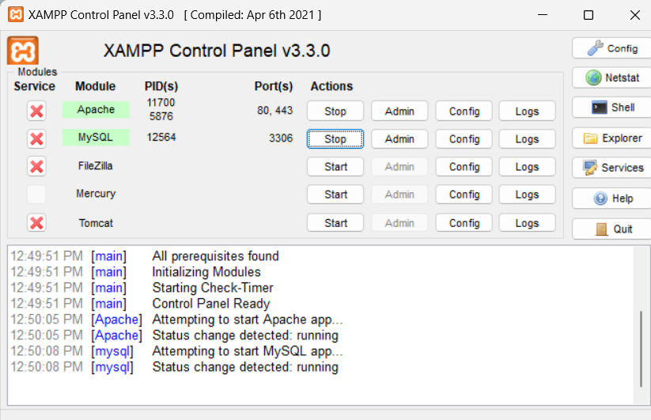This is to show the full installation of xampp….as I begin my project. myproject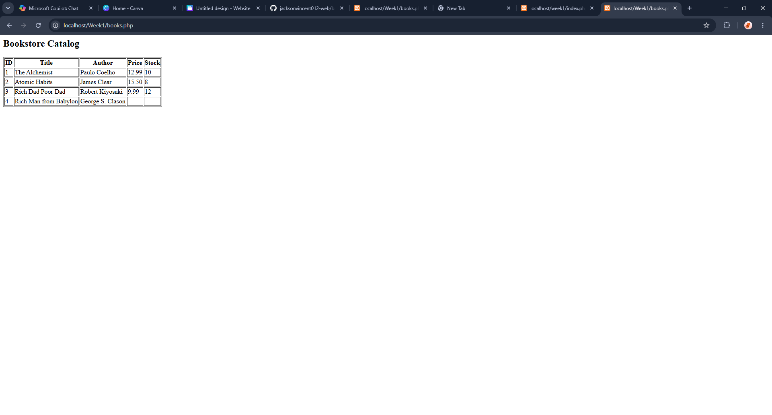
This is my first attempt to use xamp……so I made a simple bookstore catalogue.

WEEK 1 REFLECTIONS
Set up XAMPP and tested local server environment. Learned how to configure and run a basic development stack.

WEEK 2: WIREFRAMES AND GUI DESIGN.

TITLE: USER INTERFACEE PLANNING AND SYSTEM DESIGN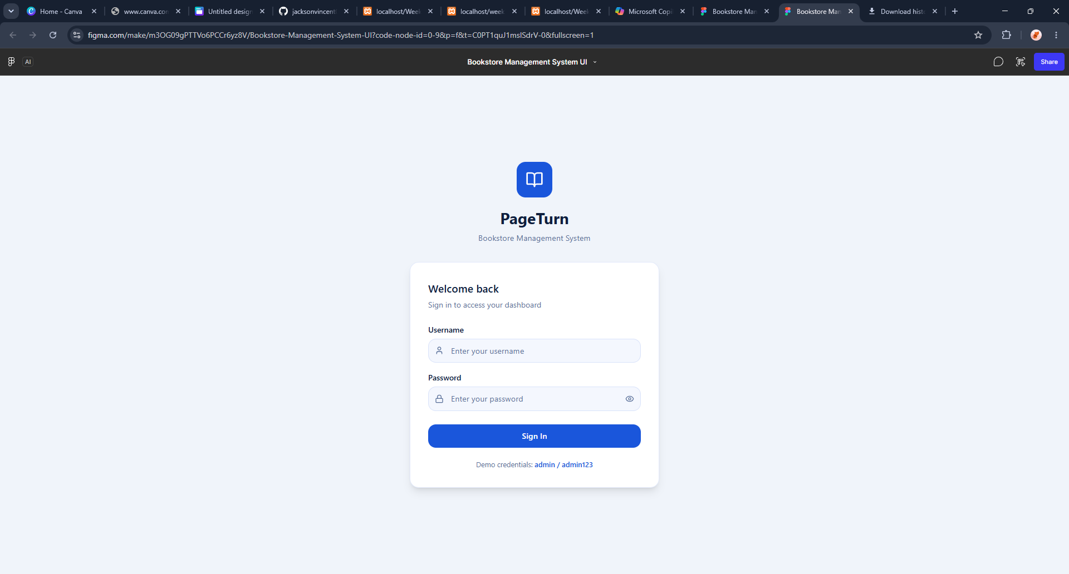
This is the log -in wire- frame how the log in page will look like.

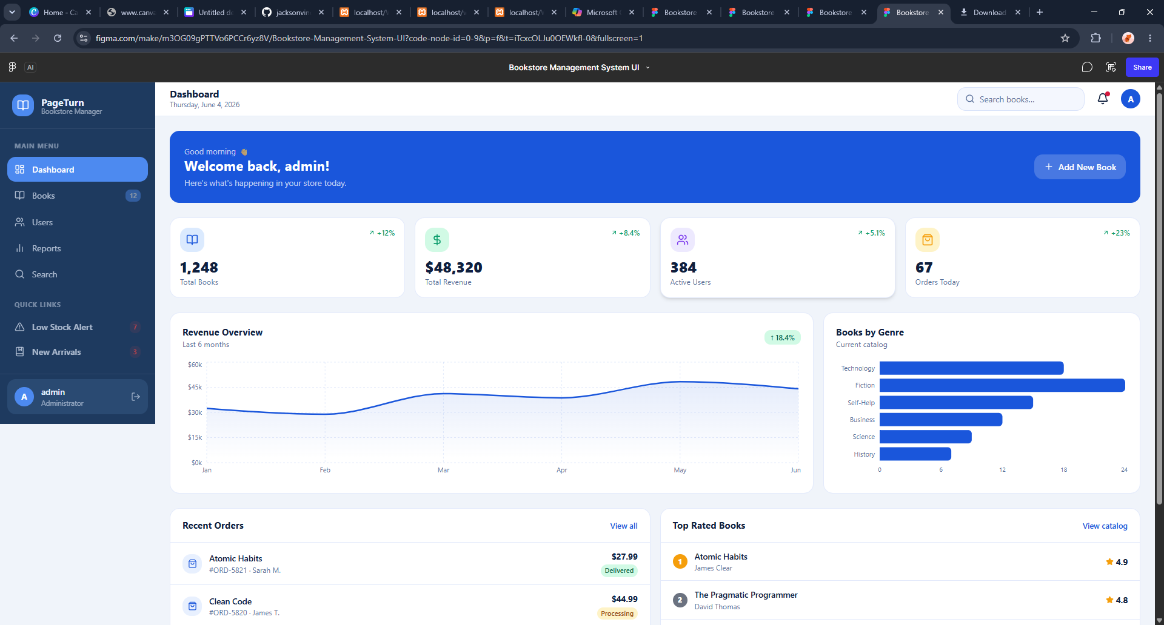
This is now our prototype made using figma wire-frame how the system design will be like

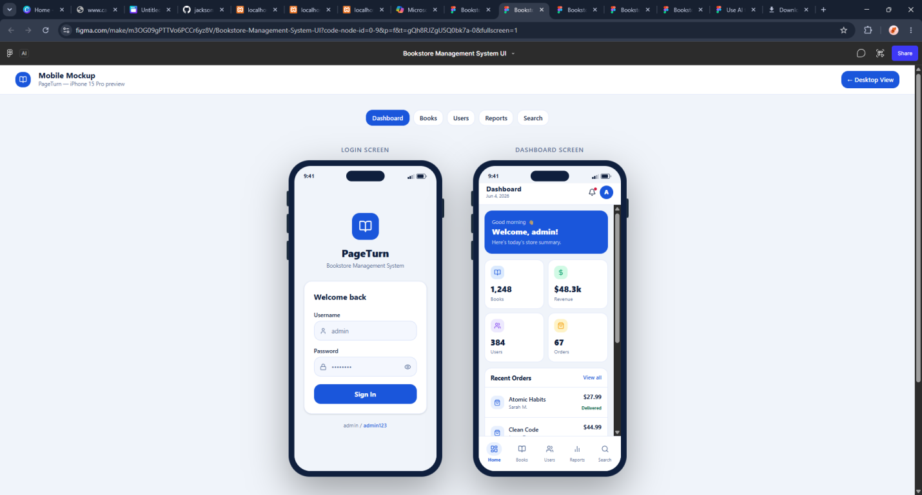
This figure shows the mobile mockup how the system will look in a phone .
Week 2 Reflection.

Learned how wireframes and mockups guide the development process .

Week3

TITLE: Frontend Interaction
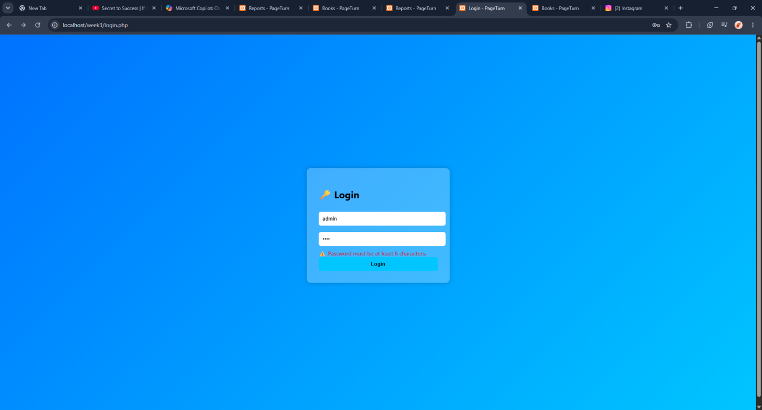
Designed log-in page that is familiar to my wireframe.
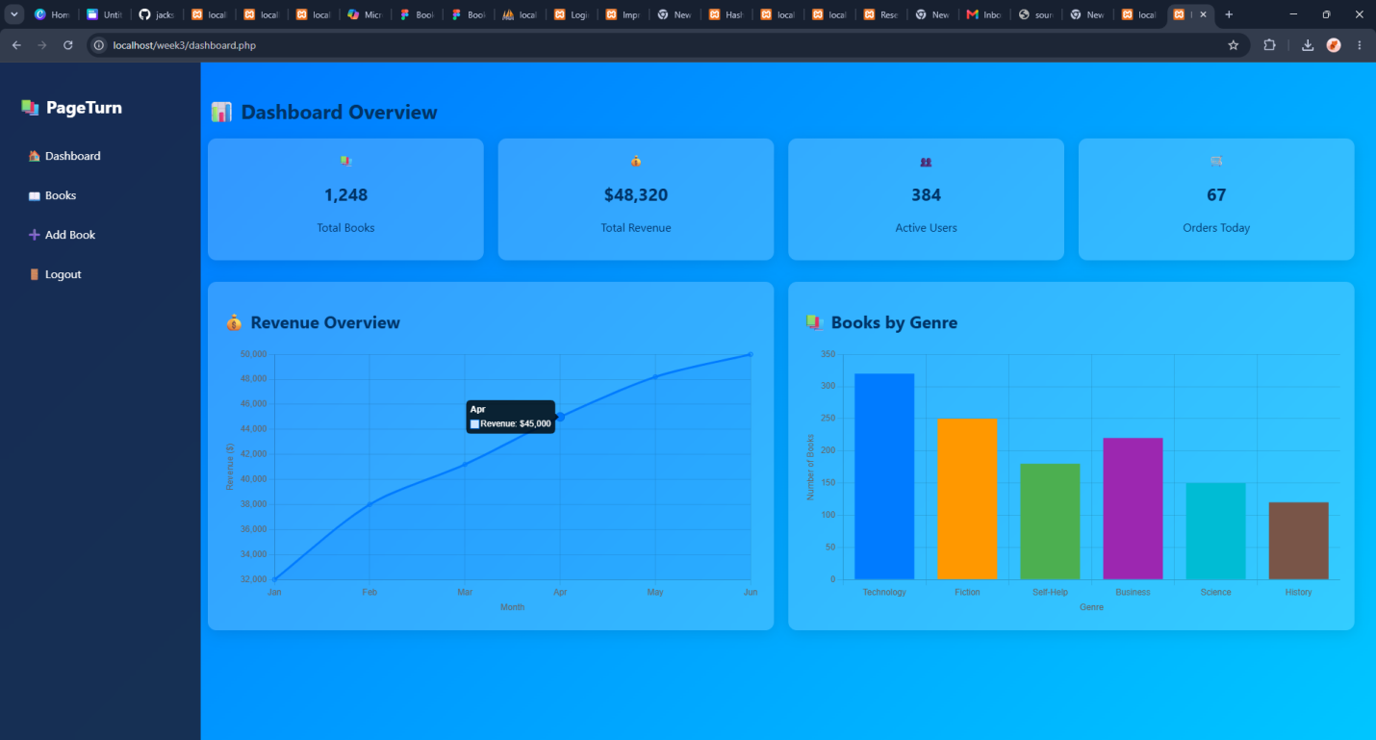
This figure shows the dashboard where you can add a book
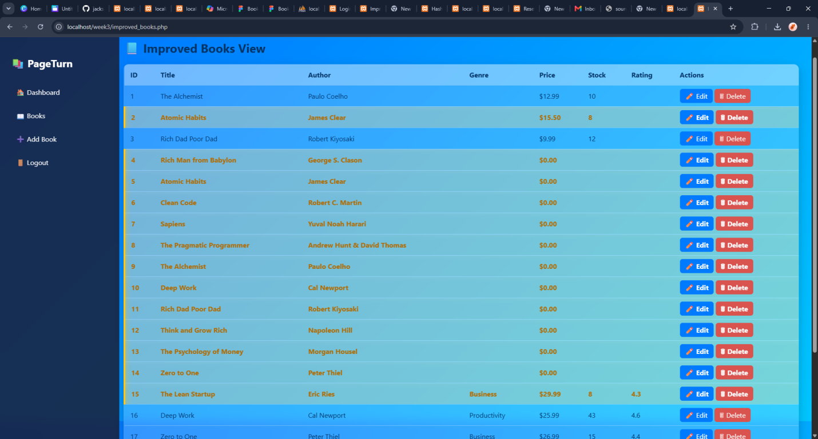
Front end showing CRUD

Week 3 Reflection
Built login page and dashboard with CRUD basics. Learned frontend validation and PHP integration.

Week 4:
Week 4: Secure Login & Dashboard Integration
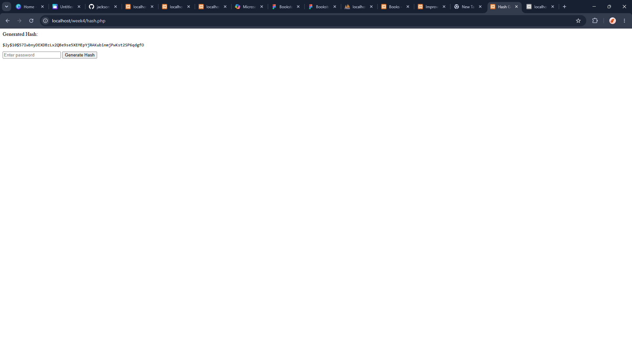
The figure above shows hashed data which is encrypted

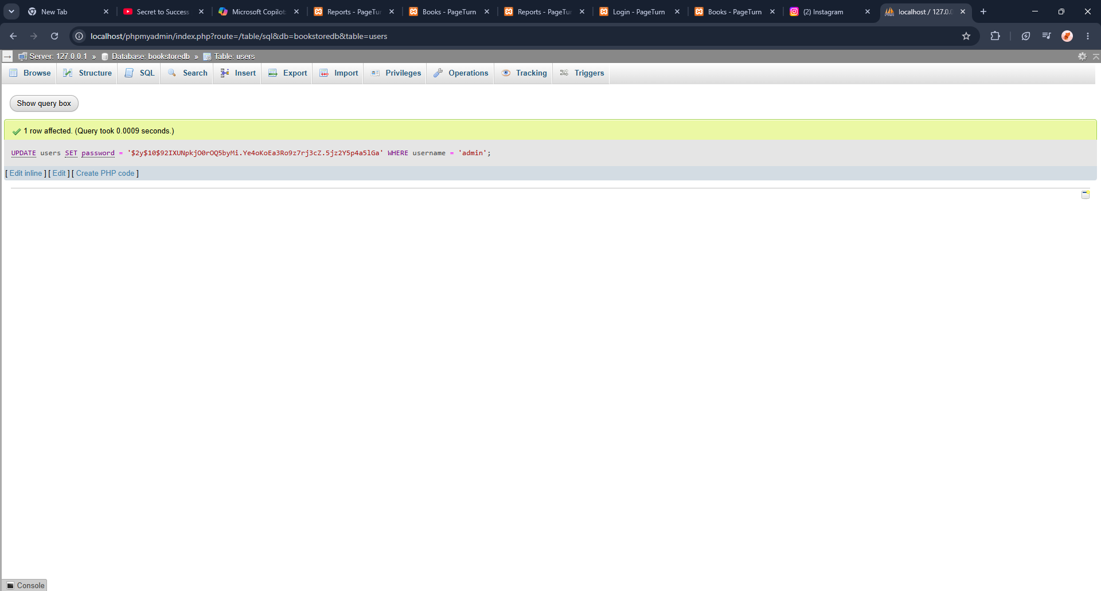
The figure above shows the password is saved in bookstore database in my php admin

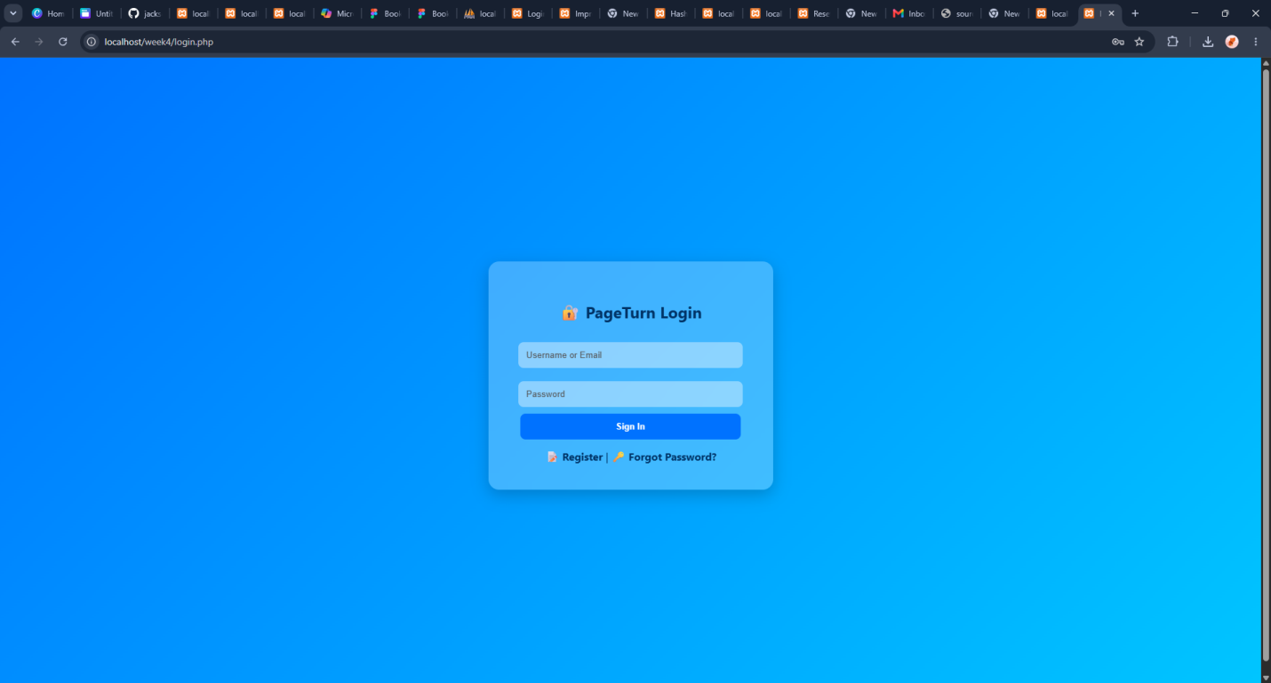
This figure above shows the well designed login page that has security and can identify null users.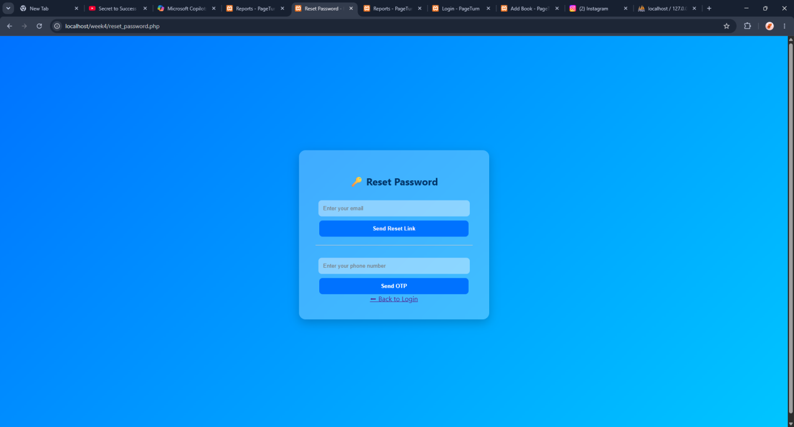
Extended log-in details if incase the user forgot his password and authentification is required.
Week4 reflection;
Implemented secure login with password hashing. Gained skills in authentication and user data protection.

Week5
Week 5: Database CRUD & Reporting
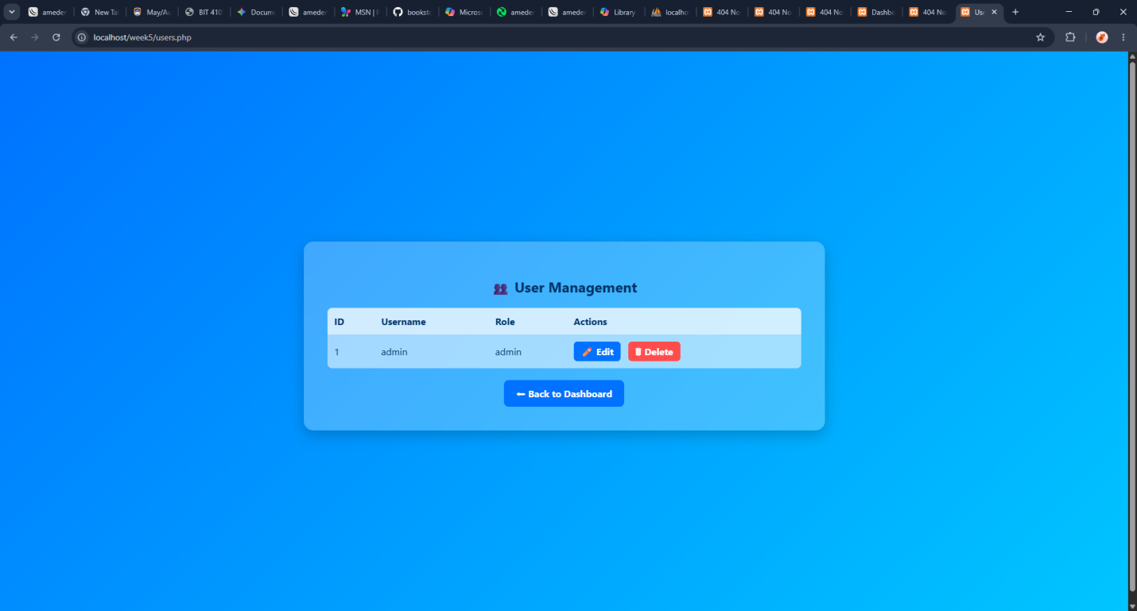
Users of book store shown in the list above.

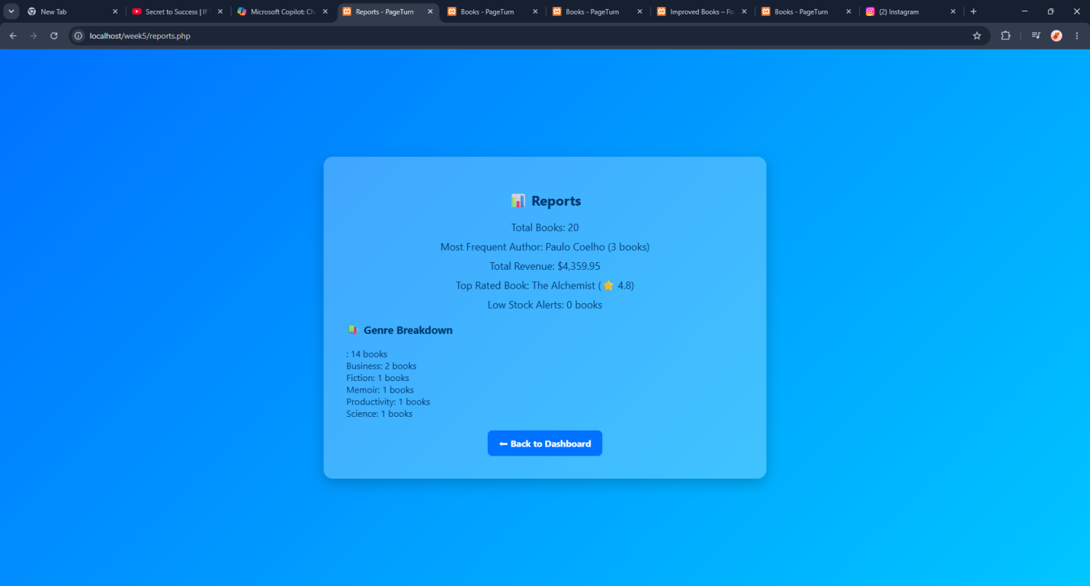
This figure shows the report of the number of books available in the book store.

Week5 reflection;
Added reporting features to CRUD dashboard. Learned how to generate and integrate database reports.
WEEK6
Week 6: Database Integration & Advanced CRUD
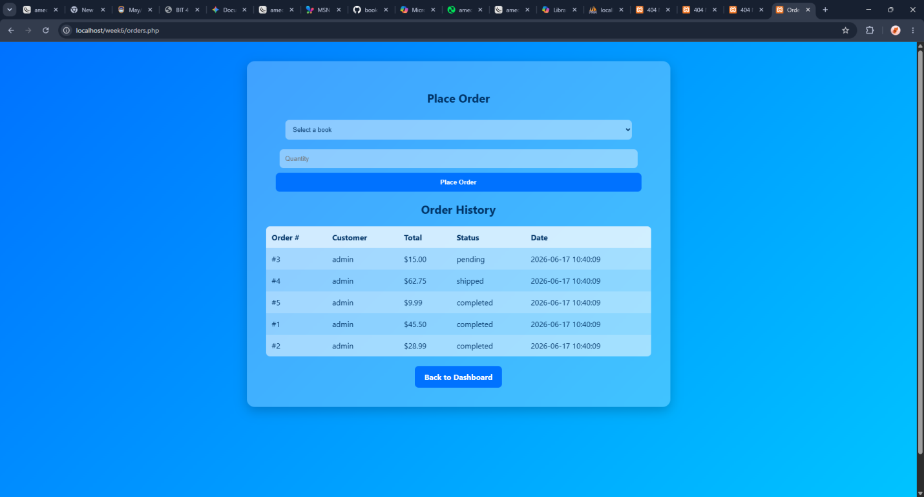
Figure above Showing orders as required in week 6
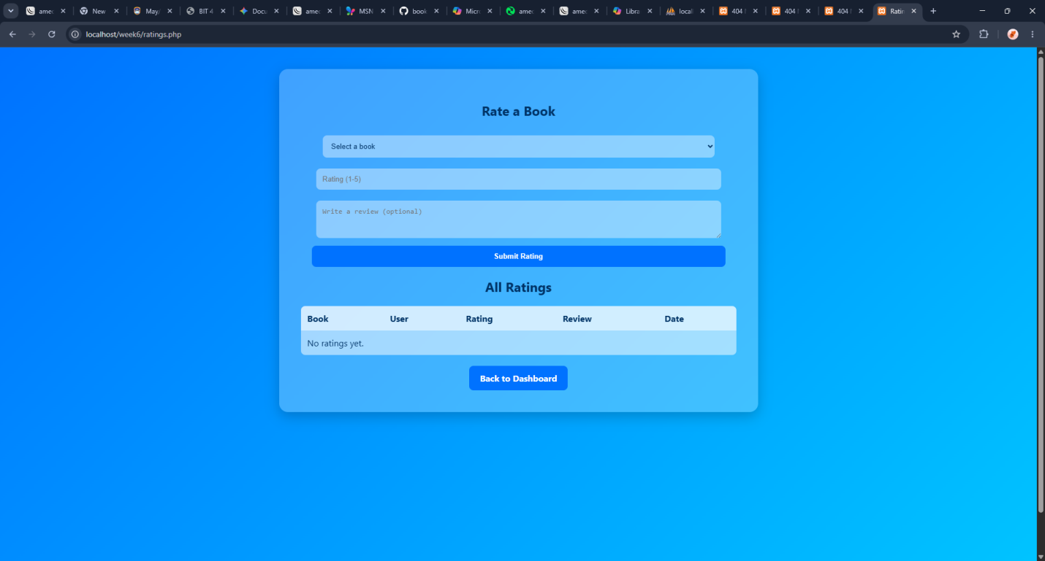
Books rating also added as shown above
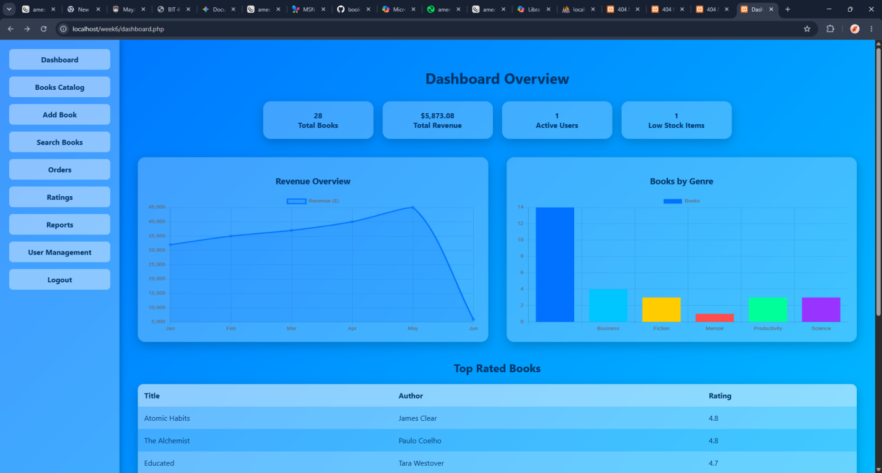
Figure above showsImproved dashboard using real db data shown below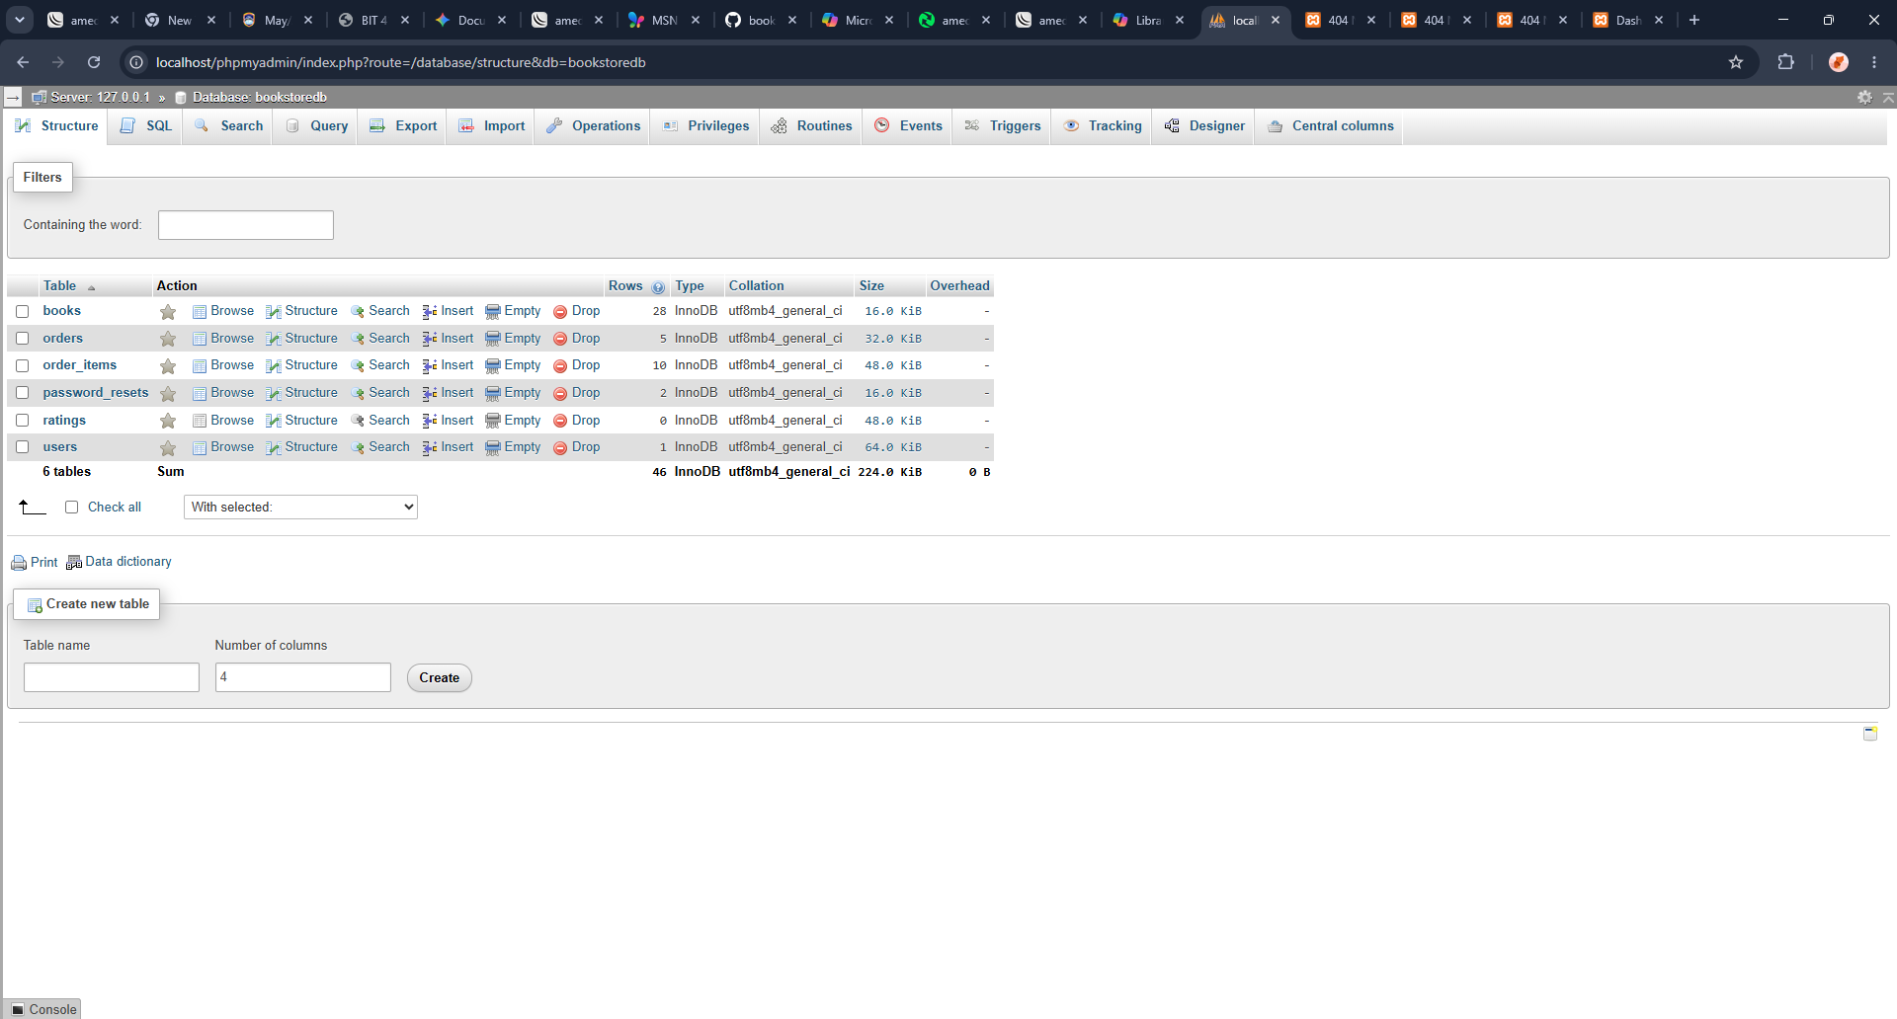
And also the CRUD implemented as below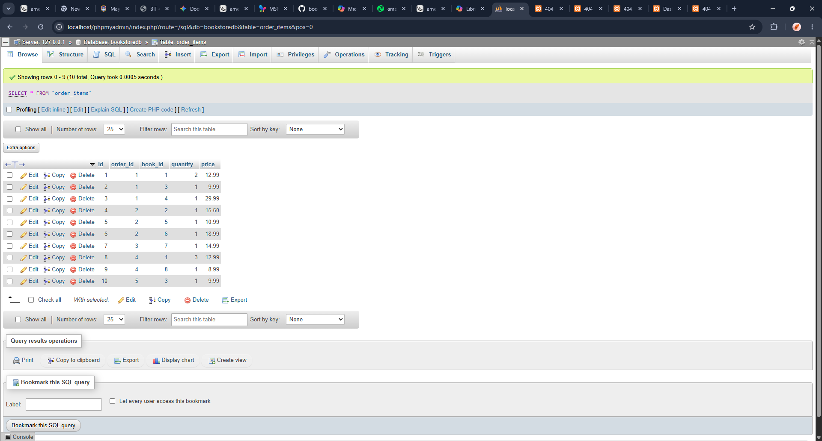
Week6 reflection;
Refined CRUD with prepared statements and validation. Strengthened secure database integration and error handling.
WEEK7
Week 7: Authentication & Session Management
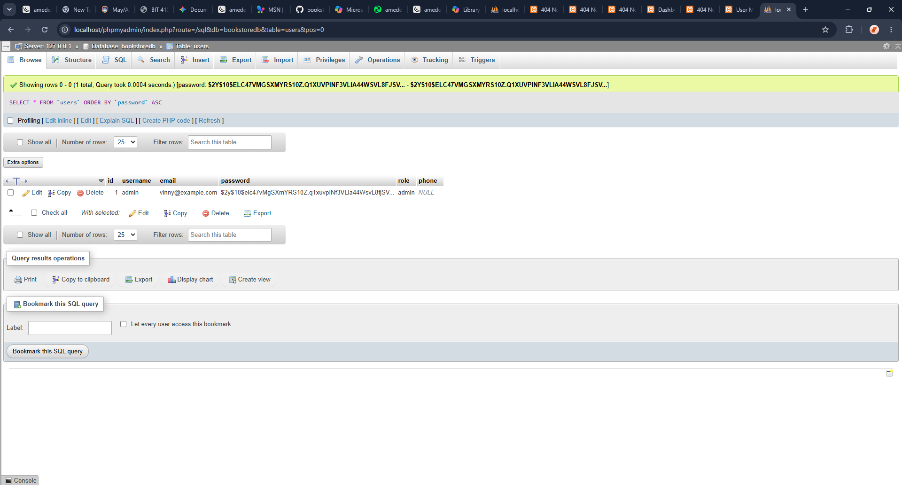
Password now stored as bcrypt hush which is now password_ verified() and also authentificaton set

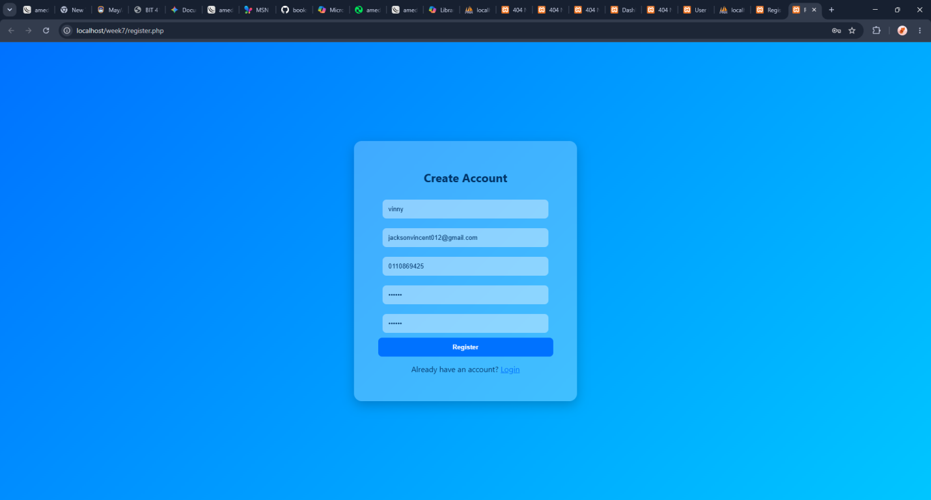
Here is the new registration form afer beeing hashed 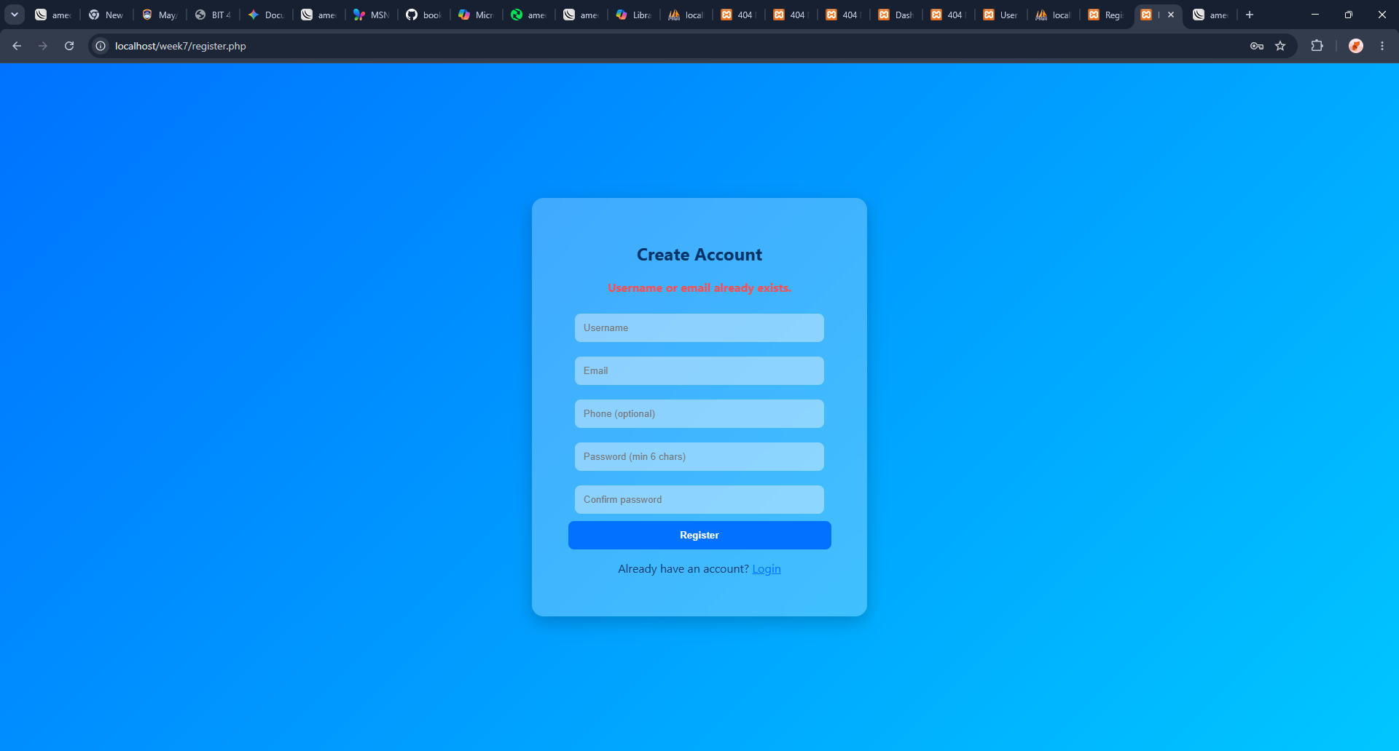
The registration restricts me to register twice once an attempt was successful.
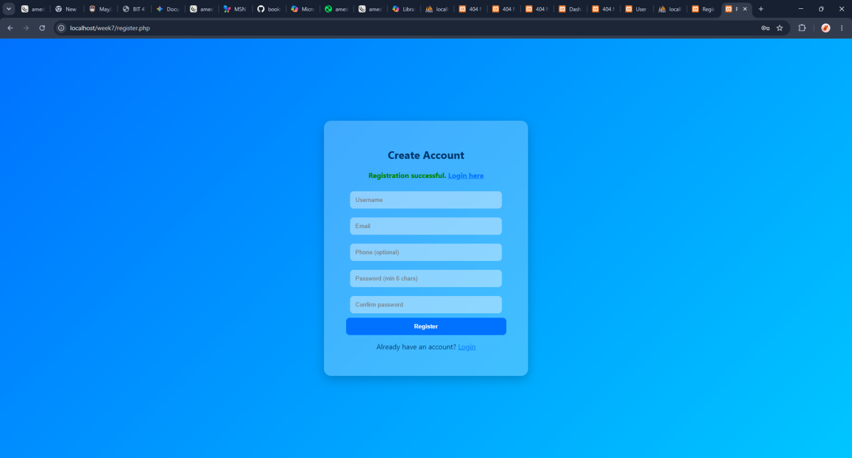
The registration succes to our login page as shown above to mean authentification verified and was successful
Week7 reflection;
Learned how to implement secure authentication systems, manage sessions and restricted pages, and strengthen skills in user access control with proper logout handling.
WEEK 8

Week 8: Responsive Web Design & Mobile-First Development

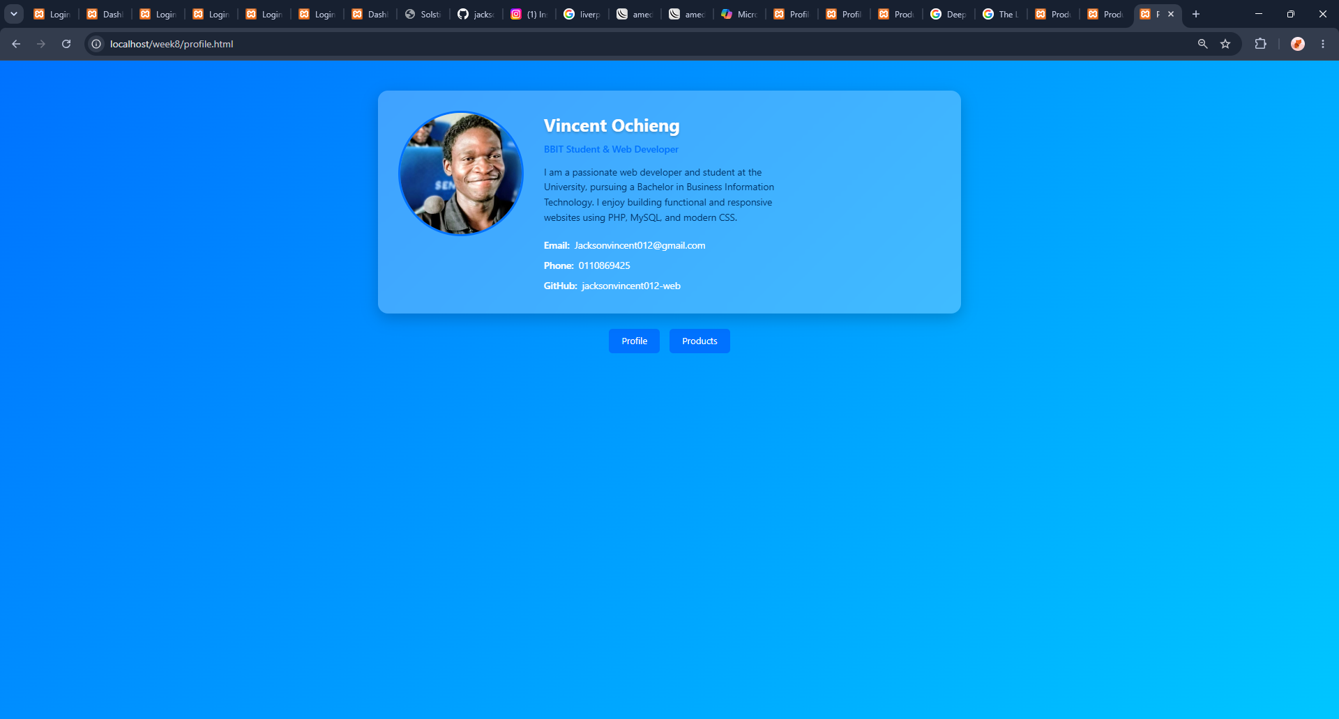
With the skills I attained in the process helped to design this profile with Well-structured layout with responsive elements for easy navigation.
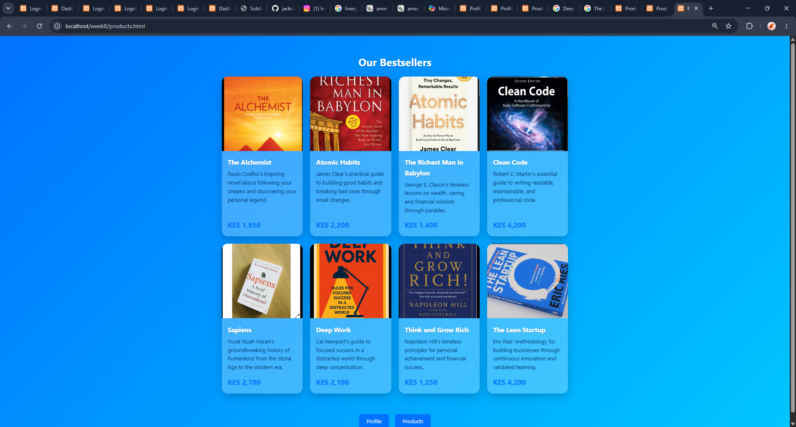
i applied media queries, Flexbox, and CSS Grid with these products

WEEK8 REFLECTION
.i Understood the importance of testing layouts across devices to ensure accessibility, usability, and consistent user experience.

